(1)

i = input()  
v = "AEIOUaeiou"  
counter = 0  
for c in i:  
 if c in v:  
 counter += 1  
print(counter)

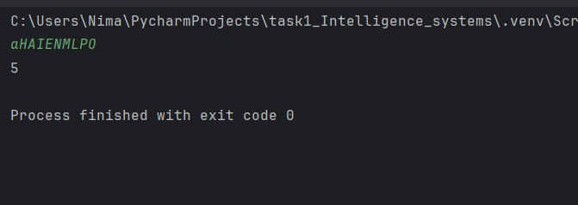

(2)

def ll(x, y):  
 return [y + i for i in range(x)]  
  
x = int(input())  
y = int(input())  
  
print(ll(x, y))

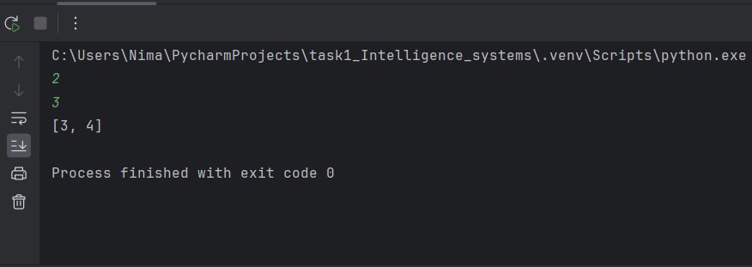

(3)

#code 3  
a = []  
for i in range(5):  
 n = int(input())  
 a.append(n)  
print(a)  
a.sort()  
print(a)  
  
a.sort(reverse=True)  
print(a)

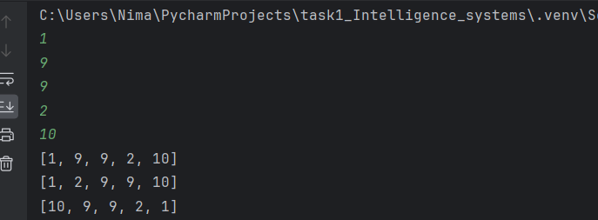

(4)

def ll(n):  
 if n % 3 == 0 and n % 5 == 0:  
 return "FizzBuzz"  
 elif n % 5 == 0:  
 return "Buzz"  
 elif n % 3 == 0:  
 return "Fizz"  
 else:  
 return n   
for i in range(3):  
 n = int(input())  
 print(ll(n))

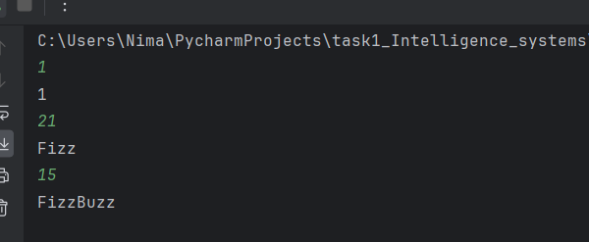

(5)

def ll(s):  
 return s[::-1]  
s = input()  
print(ll(s))

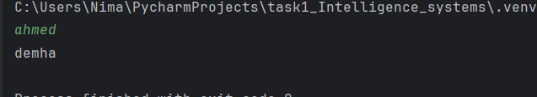

(6)

import math  
r = float(input())  
a = math.pi * r**2  
c= 2 * math.pi * r  
  
print("a:", a)  
print("c:", c)

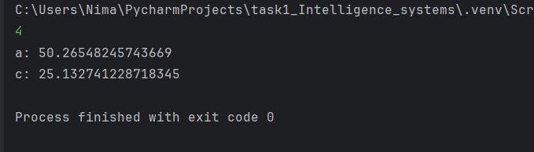

(7)

#code 7  
import re  
while True:  
 name = input("name: ").strip()  
 if name and not name.isdigit():  
 break  
 print("Invalid")  
while True:  
 email = input("email: ").strip()  
 if re.match(r"[^@]+@[^@]+\.[a-zA-Z]{2,}", email):  
 break  
 print("Invalid")  
print("name:", name)  
print("email:", email)

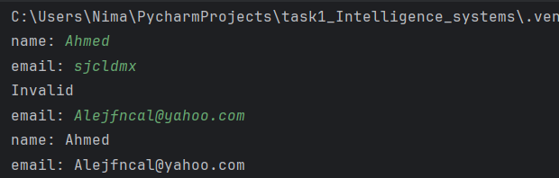

(8)

# code 8  
i = input()  
c = i.count("iti")  
print(c)

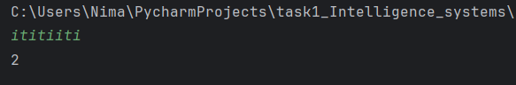

(9)

def longest_alphabetical_substring(s):

longest = current = s[0] # Start with the first character

for i in range(1, len(s)): # Loop through the string

if s[i] >= s[i - 1]: # If letters are in order

current += s[i] # Add to current substring

else:

if len(current) > len(longest): # Check if current is longest

longest = current

current = s[i] # Reset current substring

if len(current) > len(longest): # Final check

longest = current

print("Longest substring in alphabetical order is:", longest)

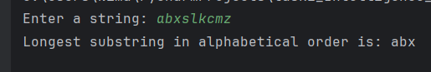

# Example usage

s = input("Enter a string: ")

longest_alphabetical_substring(s)